Darkness to Light – Week 1

1 John

- Ever since the foundation of the church about 2000 years ago it has primarily been placed in a dark area. The church has always had the purpose of being a beacon of light and of hope.
  - Have you ever driven by our church at night? It is extremely dark and all of a sudden in the middle of a pasture stands this church that is shining light and illuminating the darkness.
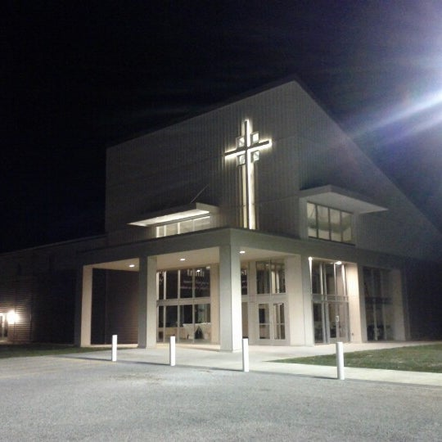
  - As great as it would be to say that this is what I mean, when the sermon is over that is not the case.
- As many of you know, when we say the church, we are not talking about a building we’re talking about people. And if you are a follower of Jesus Christ, we are talking about you.
- How do we become a part of this? How did this all begin for the church? And how do we get this directive of being the light by living in light.
- 1 John 1: 1-10
  - John is going to answer some questions and state certain things boldly because some scholars believe he is writing to a church that is struggling with inappropriately tolerating certain things.
  - Which sounds strangely familiar to the church of today many times.
  - Read 1 John 1
- There are times in our life that we need to look back and remember, look back and reflect, look back and celebrate. John is reminding us not only of Jesus’ journey the reality we live with, as well as a crossover opportunity.

Jesus Journey

- Vs. 1-2 that which was from the beginning
  - John 1: 1-2, in the beginning was the word, the word was with God and the word was God. He was in the beginning with God.
  - Jesus’ journey started in the beginning
  - Vs. 2 His life was made manifest
    - Manifest – made clear
    - Clear to where people saw Him
    - That same word is found in 2 Tim: 1
      - Read 2 Tim 1: 8-10
    - Through the manifestation of Jesus, the gospel becomes clear
      - Vs. 3 John is saying that he has seen Jesus, he has seen the manifestation of God, he is proclaiming that to people and then says that this is how you are able to enter into fellowship with God, through Jesus and Jesus alone
      - Gospel
        - Good news
        - The plan that God had to save the world by 2 Tim 1:10 abolishing death and bringing life to mankind once again
  - The journey that Jesus had to take was this
    - In the beginning
      - Perfect unity in heaven
    - Came to a sin cursed world
    - Lived a sinless life
    - Was beaten and crucified
      - Willing but did not want to
    - Died
    - Rose again
  - That is how he abolished death and brought life
  - This was the plan
  - This is the good news
  - This is the gospel
  - The journey of Jesus that he went on to have a chance at a relationship with you
The Reality
- The reality that we live with is there is darkness and there is light
  - Darkness – it hides, it covers, it deceives, it plays tricks on the mind, it blinds, it adds fear
    - Example of walking around your house at night, it slows you down, it causes more pain, it adds fear to your step
  - Light – shows truth, shows beauty, exposes blemishes, allows honest evaluation
    - Walking around that same house in the light vs. the dark
    - Story of arriving to a destination when it’s night and the view of the morning
- Vs. 5 God is light and in him there is no darkness at all.
  - Darkness and light do not mix. There is not a grey in between area
  - This new American standard way of living is that you are supposed to tolerate (fully accept) everyone and their lifestyle.
  - This is not true. Tolerance means - the ability or willingness to tolerate something, in particular the existence of opinions or behavior that one does not necessarily agree with.
  - The American society says that I must agree with you. There are people that I will look in the eye and say you are wrong. However, I still love you and I still value you.
  - This is not a hate message but rather it is a message of Love because this is the book that I believe tells us the best way to live.
  - When talking about these issues many times we like to run to Facebook and post our beliefs and how we feel about the situation, but we have to start with Jesus. Because in Jesus there is light and no darkness.
    - When we start with the issue and tag on Jesus, we mess it up and come across as hateful. But when we start with Jesus and view the issue under his light that is where we begin to handle it with love
    - God’s light does not change according to culture.

- If you are walking in darkness you are not walking with God and do not have fellowship with Him.
  - Vs. 6 if we say we have fellowship with him while we walk in darkness we lie and do not practice the truth.
  - Its more than just talking a good game, Say vs do
  - We must constantly examine our lives because walking with Jesus is not just a prayer you pray when you’re a little kid, that prayer is where and when the journey begins.
    - That is the point the crossover happens, from walking in darkness to walking in light.
      - Compare walking in darkness to walking in light
        - Darkness – scared, fear, pain, a room full of lies, unloved, hidden, unseen, ashamed
        - Light – confidence, boldness, with an identity, passion, truth, knowing your position, knowing who’s you are, knowing you are loved, knowing you are valued, not carrying pain, and hurt on your own
    - I’m not degrading the effectiveness of that prayer, but I’m stating the reality of it.
- The Reality that we live in:
  - Everyone has sinned, vs. 10
    - Vs. 10 and vs. 8 If we say we have no(t) sin
    - we deceive ourselves
    - we make Him a liar and His truth/word is not in us
  - So, the reality is that we have all walked in darkness, the reality is that we have all sinned but this is where the gospel, the good news, the manifestation of Jesus enters
  - Vs. 9 If you repent, He is faithful
    - Vs. 9 if we confess our sins, He is faithful and just to forgive us our sins and cleanse us from all unrighteousness.
      - People struggle with this; we like to say God I’ll follow but we don’t like to repent. It’s a necessity you have, in order to become clean.
  - Jesus is the one who cleanses us, and we must keep that in mind
    - We have our initial salvation that we have to repent from and confess all our sins
    - We have our ongoing sin that we continue to have to repent of
  - Vs. 7 But if we walk in the light as He is in the light, we have fellowship with one another and the blood of Jesus His son cleanses us from all sin
    - Walk in the light, Walk in the footsteps of Jesus.
    - James 1:22 says to be doers of the word not just hearers of the word.
  - Galatians 5:17 For the desires of the flesh are against the Spirit, and the desires of the Spirit are against the flesh, for these are opposed to each other, to keep you from doing the things you want to do.
    - Our fleshly desire is to be drawn to the darkness, is drawn to cover things up because we do not like to be exposed and it’s difficult to walk in the light.
    - Because what if People find out my sin?
    - What if my wife, kid, husband, parents, friends find out what has been going on
    - I have never met anyone who has said I wish I would not have come clean I wish I would have stayed in the darkness.
  - God is faithful and will lead you as you walk in the light.
- Remember the journey that Jesus went on the reality of light and darkness that we live in and the crossover opportunity we all have and have to share.

